Information Fusion 30 (2016) 15–26
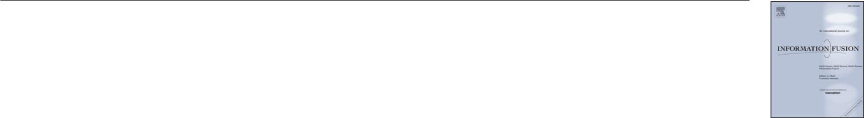
Contents lists available at ScienceDirect

Information Fusion

journal homepage: www.elsevier.com/locate/inffus

Perceptual fusion of infrared and visible images through a hybrid multi-scale decomposition with Gaussian and bilateral filters

Zhiqiang Zhou, Bo Wang∗, Sun Li, Mingjie Dong
School of Automation, Beijing Institute of Technology, 5 South Zhongguancun Street, Haidian District, Beijing 100081, PR China

a r t i c l e i n f o

Article history:

Received 29 July 2014 Revised 8 September 2015 Accepted 5 November 2015

Available online 12 November 2015

Keywords:

Multi-scale decomposition Image fusion

Gaussian filter Bilateral filter Human perception

a b s t r a c t

In order to achieve perceptually better fusion of infrared (IR) and visible images than conventional pixel-level fusion algorithms based on multi-scale decomposition (MSD), we present a novel multi-scale fusion method based on a hybrid multi-scale decomposition (hybrid-MSD). The proposed hybrid-MSD transform decom-poses the source images into multi-scale texture details and edge features by jointly using multi-scale Gaus-sian and bilateral filters. This transform enables to better capture important multi-scale IR spectral features and separate fine-scale texture details from large-scale edge features. As a result, we can use it to achieve better fusion result for human visual perception than those obtained from conventional multi-scale fusion methods, by injecting the multi-scale IR spectral features into the visible image, while preserving (or prop-erly enhancing) important perceptual cues of the background scenery and details from the visible image. In the decomposed information fusion process, three different combination algorithms are adaptively used in accordance to different scale levels (i.e., the small-scale levels, the large-scale levels and the base level). A regularization parameter is introduced to control the relative amount of IR spectral information injected into the visible image in a soft manner, which can be adjusted further depending on user preferences. Moreover, by testing different settings of the parameter, we demonstrate that injecting a moderate amount of IR spec-tral information with this parameter can actually make the fused images visually better for some infrared and visible source images. Experimental results of both objective assessment and subjective evaluation by human observers also prove the superiority of the proposed method compared with conventional MSD-based fusion methods.

© 2015 Elsevier B.V. All rights reserved.

1. Introduction

Infrared (IR) and visible image fusion is an important technique in multi-sensor information fusion applications. Since IR sensors are able to capture thermal information in a scene that is not directly seen by human eyes, they can more clearly detect some objects in low-light, occlusion and adverse weather conditions. Visible imagery normally provides more details of the scene in the visible spectrum, and also presents more natural intensities and contrasts that are con-sistent with human visual perception. Integrating IR and visible infor-mation into a fused image allows us to construct a more complete and accurate description of the scene. However, due to heat emissions and differing spectral sensitivities, the relative luminance response in the IR spectrum is quite inconsistent with that in the visible spectrum, which makes the IR imagery hard to be interpreted. As a result, the fu-sion result of IR and visible imageries may also be visually unpleasing

∗ Corresponding author. Tel.: +86 010 68914781.
E-mail address: wangbo.bitauto@gmail.com (B. Wang).

http://dx.doi.org/10.1016/j.inffus.2015.11.003 1566-2535/© 2015 Elsevier B.V. All rights reserved.

for human observers. Therefore, besides determining the best way to take full advantage of all information of the two source images in the fusion process, a more significant task should be to make the fused image easy to be interpreted, and thus can lead to better situation awareness.

To fuse thermal IR and visible imageries, many algorithms have been proposed by considering principles of biological color vision. Waxman et al. [1] introduce opponent-color neural networks to pro-duce the fused image with false colors. Since a proper color repre-sentation of the fused image can allow for better scene interpreta-tion, color remapping is usually used additionally in these methods to generate more natural colors. However, a highly natural coloring is diﬃcult since the IR relative luminance response is quite different with that in the visible spectrum. With the assistance of a natural daytime color reference image, Toet et al. [2,3] managed to use a color mapping method to obtain natural color representation of the night-vision fusion results.

A more common approach for pixel-level image fusion is con-ducted in grayscale space based on various multi-scale decompo-sition (MSD) transforms, e.g., Laplacian pyramid (LAP) [4], gradient

16 Z. Zhou et al. / Information Fusion 30 (2016) 15–26
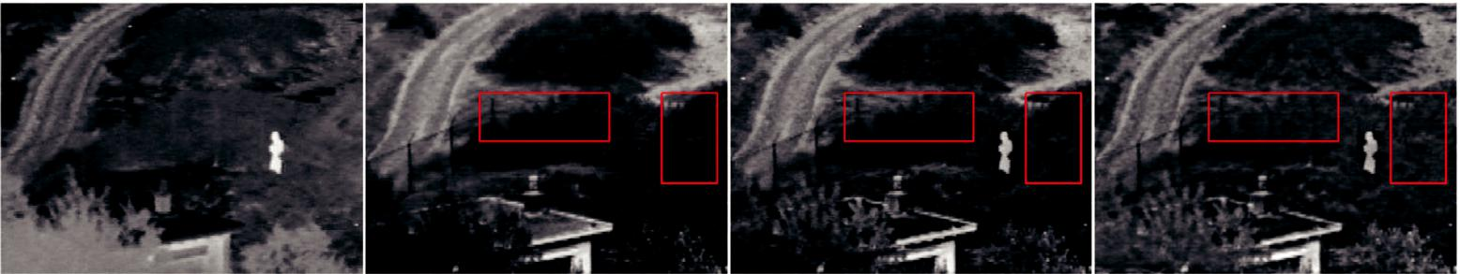

(a) Infrared image (b) Visible image (c) Our fusion result (d) Fused by DT-CWT

Fig. 1. The results of our fusion method and the conventional DT-CWT fusion method on the “UN Camp” source images.

pyramid (GP) [5], wavelet transform [6] and support vector trans-form [7]. For these MSD-based fusion methods, MSD transforms are performed first on each source image to obtain different subbands containing the decomposed information of different frequencies or orientations. The corresponding subbands of all source images are then combined together based on certain fusion rules. Finally, the fused images can be produced by inverse MSD transforms. To merge thermal and visual images, Toet et al. [8] propose one of the earliest MSD transform named contrast pyramid or ratio of low pass pyramid (ROLP). The ROLP is formed as a ratio of each level of Gaussian pyra-mid to its next coarser-level one. Fusion with ROLP enables to identify and preserve important high-contrast details that are more relevant to visual perception.

Other more complex MSD transforms including dual-tree complex wavelet (DT-CWT), curvelet and contourlet have also been success-fully applied in image fusion [9–13]. These MSD transforms achieve better properties of shift invariance and directional selectivity, which are essential for multispectral image fusion since they enable to correctly transfer more directional details into the fused image. However, since the IR imagery usually presents large differences in relative luminance response (and thus may generate coarser-scale in-formation, rather inconsistent contrasts or different edges and con-tours, etc.) against that of the corresponding visible imagery, directly combining the two image salient features based on these conven-tional MSDs may clutter the image content in the fusion result and make it visually unpleasing (e.g., blurring of details, introducing un-natural contrasts or visual artifacts).

In this paper, we present a novel multi-scale fusion method based on a hybrid MSD transform (hybrid-MSD) to achieve better fusion re-sults for human visual perception. Unlike the previous MSD trans-forms that attempt to capture more directional information with comparatively more complex filters, the hybrid-MSD decomposes the source image into texture details and edge features at multiple scales by jointly using multi-scale Gaussian and bilateral filters. In a perceptual evaluation of different image fusion schemes, Toet et al. [14] indicate that the IR imagery serves best for target detection and recognition, whereas the visible imagery contributes most to global scene awareness. Our method manages to employ the hybrid-MSD as well as a novel asymmetrical multi-scale fusion scheme to in-ject the important IR spectral features into the visible image, while preserving (or properly enhancing) important perceptual cues of the background scenery and details captured from the visible spectrum. Thus, it would lead to perceptually better fusion results for human interpretation.

A fusion example can be seen in Fig. 1. While the conventional DT-CWT method tends to transfer all the irrelevant details from the in-frared image into the fused image and make the visible details of the background scenery (e.g., the fence and trees labeled in the rectangles of Fig. 1(d)) less clear for visual perception, our fusion method better preserves the background scenery and details from the visible image overall (see Fig. 1(c)). The rest of this paper is organized as follows. In

Section 2, the concept and construction of the hybrid-MSD based on Gaussian and bilateral filters are presented. In Section 3, we can see the hybrid-MSD can be used to select important multi-scale IR spec-tral features from the infrared image. Hence, an asymmetrical fusion scheme is then proposed to inject the selected IR spectral features into the visible image. By cooperating with three different combina-tion algorithms adapted to different decomposed-information scale levels, we can simultaneously preserve or properly enhance the back-ground scenery and details from the visible image in the fusion pro-cess. Experimental results and comparisons are given in Section 4. Conclusions are presented in Section 5.

2. The hybrid-MSD based on Gaussian and bilateral filters

Gaussian and bilateral filters are both known as important filter-ing methods extensively used in image processing applications. The Gaussian filter is one of the basic tools for noise reduction and image smoothing. The linear scale-space representation of an image is con-structed via the convolutions with a series of Gaussian kernels [15]. Computing with repeated Gaussian filtering and downsampling, we can also obtain the Gaussian pyramid. Based on this pyramid struc-ture, several MSD transforms including the LAP, ROLP and GP have been proposed and employed in image fusion.

The bilateral filter is a non-linear edge-preserving filter that can smooth small-scale details while preserving strong edges [16]. It fil-ters images in the spatial and range domains simultaneously through the combination of spatial and range Gaussian kernels. With a Gaus-sian function denoted as g_{σ} (x) = exp (−x²/σ ²), the bilateral filtering of image I at pixel p is performed as:

 |  | 1 | ∈ | ( p − q )g_{σr} | (|I(p) − I(q)|)I(q),
^{I}b^{(p)} ⁼ _{W} _{q} ^{g}σs |  |  |  | ( p − q )g_{σr} | (|I(p) − I(q)|)I(q), | (1)
with
∈ |  | g_{σs} ( p − q )g_{σr} (|I(p) − I(q)|),
W = |  |  |  |  |  | (2)
q

where σ _{s} and σ _{r} are the standard deviations of the spatial and range Gaussians, which control the influences of neighboring pixel q in terms of spatial and intensity differences, respectively. ∈ R² rep-resents the image domain.

By setting a relatively small value of σ _{r}, we can obtain a bilateral filtered image I_{b} that retains the “large-scale features” separated by strong edges [17], and removes the fine-scale details that are dom-inated by texture features. Furthermore, assuming I_{g} is the corre-sponding Gaussian filtered image that is computed by solely using the spatial Gaussian g_{σs} ,we can see that I_{b} contains certain additional edge information compared with I_{g}. Consequently, we can obtain the removed fine-scale texture details D⁰ and the additional edge fea-tures D¹ retained in I_{b} by the following subtractions respectively:

D⁰ = I − I_{b}, | (3)

 | Z. Zhou et al. / Information Fusion 30 (2016) 15–26 |  | 17
I ⁰ | I_{g}¹ | I_{g}² | I_{g}³
I_{b}¹ |  | I_{b}² | I_{b}³
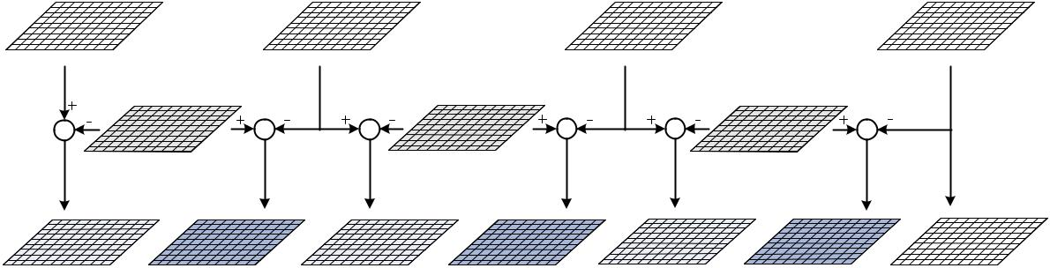

_{D}(1,0) _{D}(1,1) _{D}( 2,0) _{D}( 2,1) _{D}(3,0) _{D}( 3,1) _{B}

Fig. 2. The construction of a three-level hybrid-MSD.
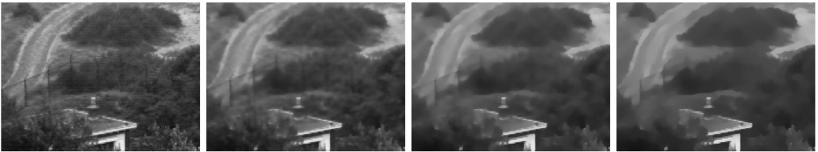

a b c d

Fig. 3. Texture details are successively smoothed (from left to right) while strong edges are preserved by setting σ_{s,} _{j+1} = 2σ_{s,} _{j} and σ_{r,} _{j+1} = σ_{r,} _{j} /2, where σ_{s,0} = 2.0,σ_{s,0} = 0.1 are used ( the grayscale is normalized to [0, 1]).

D¹ = I_{b} − I_{g}. | (4)

The decomposition (3) enables to separate image texture details from a base layer. This two-scale decomposition has been used to var-ious image processing applications via information manipulating on different layers separately, such as high dynamic range compression [18], tone management [19], digital photography [20] and relighting [17]. In order to enhance the shape and surface details of an object from multi-light image collections, Fattal et al. [21] extend it into a multi-scale decomposition and successfully avoid the halo artifacts usually introduced by the traditional Laplacian pyramid. In addition to the decomposition (3), we also use the decomposition (4) since it allows separating large-scale edge features from the fine-scale tex-ture details [22]. Furthermore, we generalize this hybrid decomposi-tion into a multi-scale representation in a manner that is similar to the multi-scale bilateral decomposition presented in [21], and then demonstrate how this proposed hybrid-MSD can be used to fuse the infrared and visible images to allow for better visual perception.

The construction of a three-level hybrid-MSD is illustrated in Fig. 2, where I_{g}^{j} and I_{b}^{j} (j > 0) denote the jth-level Gaussian and bi-lateral filtered images, and I⁰ represents the original source image I. The decomposed jth-level texture details and edge features are ob-tained by D⁽ ^{j,0)} = I_{g}^{j−1} − I_{b}^{j} and D⁽ ^{j,1)} = I_{b}^{j} − I_{g}^{j}, respectively. The image B (B = I_{g}³ for a three-level decomposition as shown in Fig. 2) denotes the base layer of the hybrid-MSD. Therefore, the source image I can be reconstructed by adding all levels of the decomposed information on the base image as:

N
_{I} ₌ _{B} _{+(D}( j,0) ₊ _{D}( j,1)_{),} | (5)
j=1

where N denotes the number of decomposition levels. The main prop-erty of the hybrid-MSD differing from the traditional Laplacian pyra-mid is the separation of fine-scale texture details and large-scale edge features in each level of decomposition. In addition, the hybrid-MSD is essentially a nonlinear multi-scale image decomposition due to the

incorporation of multi-scale edge-preserving filters. These properties would be particularly beneficial to certain applications, e.g., the in-frared and visible image fusion discussed in this paper.

The Gaussian and bilateral filtered images are computed by the following iterative convolutions with the spatial and range Gaussians gσ_{s,} _{j} , gσ_{r,} _{j} , respectively:
_{Ig}j+1 | 1 |  |  | g_{σs,} _{j} ( p − q )I_{g}^{j}(q),
_{Ig}j+1 | (p) = |  |  | g_{σs,} _{j} ( p − q )I_{g}^{j}(q), | (6)
_{Ig}j+1 | (p) = | W_{g} |  | g_{σs,} _{j} ( p − q )I_{g}^{j}(q), | (6)
 |  |  |  | ∈
 |  |  |  | q
I_{b}^{j+1} | 1 |  |  | g_{σs,} _{j} ( p − q )g_{σr,} _{j} (|I_{b}^{j}(p) − I_{b}^{j}(q)|)I_{b}^{j}(q),
I_{b}^{j+1} | (p) = |  |  |  | (7)
I_{b}^{j+1} | (p) = | ^{W}b |  |  | (7)
 |  |  |  | ∈
 |  |  |  | q

with
W_{g} = | ∈ | ( p − q ),
W_{g} = | gσ_{s,} _{j} | ( p − q ), | (8)
 | q
W_{b} = | g_{σs,} _{j} ( p − q )g_{σr,} _{j} (|I_{b}^{j}(p) − I_{b}^{j}(q)|), |  | (9)
 | ∈
 | q

where I_{g}⁰ = I⁰ and I_{b}⁰ = I⁰. We set σ_{s,} _{j+1} = 2σ_{s,} _{j} to let the width of spa-tial Gaussian double increase across levels, and set σ_{r,} _{j+1} = σ_{r,} _{j} /2 to

ensure that strong edges can be preserved across scales while texture details are successively smoothed in the bilateral filtered images (see Fig. 3). Notice that some fast versions of the bilateral filter have been already proposed [18,21,23,24]. Thus, the hybrid-MSD can be imple-mented eﬃciently.

3. Infrared and visible image fusion based on the hybrid-MSD

Visible images often contain more fine-scale details than the corresponding infrared images, in which the thermal information is usually captured as coarser-scale structures or features. Therefore, there usually exists a large scale difference between the infrared and visible images, which can be measured in scale-spaces [25]. In ad-dition, infrared images often present unnaturally high contrasts and

18 Z. Zhou et al. / Information Fusion 30 (2016) 15–26
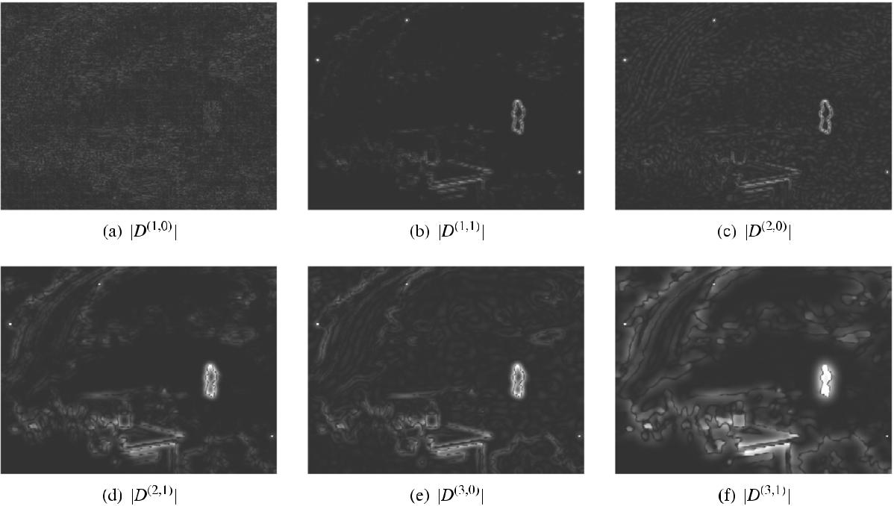

Fig. 4. A three-level decomposition of the “UN Camp” infrared image obtained by the hybrid-MSD transform.
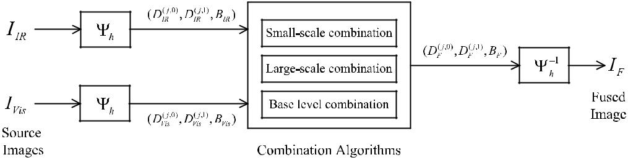

Fig. 5. The architecture of infrared and visible image fusion based on the hybrid-MSD.

intensities on the objects with relatively higher temperature than the surroundings. The luminance responses and contrasts of the same scene in the infrared and visible images can also be different. For these reasons, decomposing and then merging the two source image information directly by employing conventional MSDs without reliable feature selection may not produce a pleasant fusion result for human observation.

Fig. 4 presents a three-level decomposition of the “UN Camp” in-frared image (see Fig. 1(a)) obtained by the hybrid-MSD transform, in which the absolute values |D^{(j, 0)}| and |D^{(j, 1)}| ( j = 1, 2, 3) are con-cerned. We can see that significant IR spectral features get partic-ularly high responses in |D^{(j, 1)}|. Especially at the largest scale level these features can be even clearly identified (see Fig. 4(f)). This is because the prominent IR spectral information usually emerges as large-scale features in the infrared image and achieves high relative luminance responses which contain stronger edges. As a result, it is more associated with the large-scale edge features obtained in the hybrid-MSD. Thus, this decomposition allows us to better capture the multi-scale IR spectral features in the infrared image. Moreover, the hybrid-MSD is able to separate fine-scale texture details from large-scale edge features, which is essential for the fusion of infrared and visible images since we can better take advantage of the texture details from the visible image.

Let (D⁽ ^{j,0)}, D⁽ ^{j,1)}, B) = _{h}(I) denote the hybrid-MSD transform of the input image I, and I = _{h}⁻¹(D⁽ ^{j,0)}, D⁽ ^{j,1)}, B) be the corresponding inverse transform as defined in Eq. (5). The architecture of the pro-posed fusion system for infrared and visible images is illustrated in Fig. 5. Firstly, the input infrared and visible images I_{IR}, I_{Vis} are de-composed by the hybrid-MSD transform to obtain the multi-scale texture details, edge features and the base layer respectively as

follows:

(D_{IR}^{(j,0)}, D_{IR}^{(j,1)}, B_{IR}), | j = 1, 2, . . . , N | (10)
and
(D_{V}⁽ ^{j}_{is}^{,0)}, D_{V}⁽ ^{j}_{is}^{,1)}, B_{V is}), | j = 1, 2, . . ., N. | (11)

Then, they are merged at different scale levels by using different spec-ified combination algorithms. Finally, the inverse transform _{h}⁻¹ is employed to produce the fused image I_{F}.

Our purpose is to obtain perceptually better fusion result by in-jecting the IR spectral features into the visible image, while preserv-ing or properly enhancing the background scenery and details from the visible image in a multi-scale manner. To achieve this goal, we employ different combination algorithms adaptively in accordance to three different scale-level categories, i.e., the small-scale levels, the large-scale levels and the base level. Notice that like most of the fu-sion methods based on various MSDs, the combination algorithms proposed in our fusion method are also performed at the pixel level.

3.1. Small and large-scale combinations

Typically, at the small-scale levels we only choose the top level ( j = 1) of the decomposition. Selecting absolute maximum approach is used in this scale level to integrate all the significant fine-scale fea-tures into the fused image as follows:
( j,i) |  |  | D_{IR}^{(j,i)}, |  | | | _{D}( j,i) | | | > | | | _{D}( j,i) | | | ( j |  | 1 and i |  | 0, 1). | (12)
D_{F} | = |  | ( j,i) |  | | | IR | | |  | | | V is | | | ( j | = | 1 and i | = | 0, 1). | (12)
 | = |  | ^{D}V is | , | otherwise |  |  |  |  |  |  |  | = |  | =
The large-scale levels are chosen to include all the decomposed levels from j = 2 to j = N. At these scale levels, the decomposed

Z. Zhou et al. / Information Fusion 30 (2016) 15–26 |  |  |  |  |  |  | 19
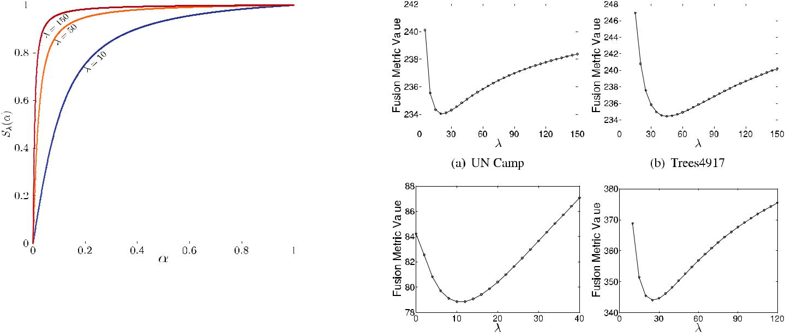
Fig. 6. the plots of S_{λ} with respect to different parameter λ.

large-scale edge features in D^{(j, 1)}are fully used to identify and de-termine the weights of corresponding IR spectral features that would be injected into the visible image. This is accomplished by computing the weighting coeﬃcients C^{j} in two steps. First of all, the significant IR spectral features at each scale level are identified by

Fig. 8. Fusion quality values with respect to different parameter λ in terms of the Chen–Varshney metric for different sets of source images (shown in Fig. 9(a)–(d)).

 |  | = |  |  | 0|, |  |  | | |  |  |  |  | | |  |  | | |  | |otherwise||, |  |  | |
_{R} j |  |  |  |  | D_{IR}^{(j,1)} |  |  |  | − |  |  |  |  |  | D_{V}⁽ ^{j}_{is}^{,1)} , |  |  | D_{IR}^{(j,1)} |  | − D_{V}⁽ ^{j}_{is}^{,1)} |  | > 0 | (13) | 3.2. Base level combination
and R^{j} is normalized by |  |  |  |  |  |  |  |  |  |  |  |  |  |  |  |  |  |  |  |  |  |  |  |  |  | The base image obtained by a MSD contains the coarsest-scale
P ^{j} |  | = |  |  |  |  | R ^{j} |  |  |  |  |  |  |  |  |  |  |  |  |  |  |  | (14) | information. Theoretically, we can keep applying the decomposing
 |  | = |  |  |  |  |  |  |  |  |  |  |  |  |  | . |  |  |  |  |  |  | (14) | process until the mean information of the source image is obtained.
 |  | = | max_{x∈} {R |  |  |  |  |  |  |  |  | j |  | (x)} |  | . |  |  |  |  |  |  | (14)
 |  |  |  |  |  |  |  |  |  |  |  |  |  |  |  |  |  |  |  |  |  |  |  | However, it is unnecessary in practice since the base image contain-
 |  | If P^{j}(x) > 0, it indicates that the point x contains certain IR spectral |  |  |  |  |  |  |  |  |  |  |  |  |  |  |  |  |  |  |  |  |  | ing a certain amount of residual low-frequency information can well
information intended to be injected into the visible image at level |  |  |  |  |  |  |  |  |  |  |  |  |  |  |  |  |  |  |  |  |  |  |  | be employed to control the overall look of the fused image. Also, it re-
j (2 ≤ j ≤ N). By further adjusting with a nonlinear function S_{λ}: [0, 1] |  |  |  |  |  |  |  |  |  |  |  |  |  |  |  |  |  |  |  |  |  |  |  | quires large number of decomposition levels which would drastically
→ [0, 1], the weighting coeﬃcients are then obtained as: |  |  |  |  |  |  |  |  |  |  |  |  |  |  |  |  |  |  |  |  |  |  |  | increase the computational work.
C | j | = g_{σc} ∗ S_{λ}(P |  |  |  |  |  |  |  | j | ), |  |  |  |  |  |  |  |  |  |  |  | (15) |  |  | Another important function of the base image in a multi-scale rep-
C |  |  |  |  |  |  |  |  |  |  |  |  |  |  |  |  |  |  |  |  |  |  | (15) | resentation is that it generally provides the support information for
where the convolution with a Gaussian g_{σc} serves to reduce noise and |  |  |  |  |  |  |  |  |  |  |  |  |  |  |  |  |  |  |  |  |  |  |  | the higher-frequency subbands. They are closely associated with each
locally smooth the weighting coeﬃcients. We typically set σ_{c} = 2. |  |  |  |  |  |  |  |  |  |  |  |  |  |  |  |  |  |  |  |  |  |  |  | other in scale-spaces. So it is reasonable that the construction of the
 |  | The nonlinear function S_{λ} in Eq. (15) is defined as: |  |  |  |  |  |  |  |  |  |  |  |  |  |  |  |  |  |  |  |  |  | fused base image would also be related to the higher-level decom-
S_{λ}(α) = arctan (λα)/ arctan (λ), |  |  |  |  |  |  |  |  |  |  |  |  |  |  |  |  |  |  |  |  |  |  | (16) | posed information in the fusion process.
 |  |  |  |  |  |  |  |  |  |  |  |  |  |  |  |  |  |  |  |  |  |  | (16) |  |  | As a result, we combine the base images by taking account of the
where α ∈ [0, 1] denotes the independent variable of the function,
 |  |  |  |  |  |  |  |  |  |  |  |  |  |  |  |  |  |  |  |  |  |  |  | higher-level weighting coeﬃcients as follows:
and λ (λ > 0) is the function parameter. Fig. 6 shows the plots of S_{λ} |  |  |  |  |  |  |  |  |  |  |  |  |  |  |  |  |  |  |  |  |  |  |  | B_{F} |  | = C_{b}B_{IR} + (1 − C_{b})B_{V is}, |  |  | (18)
with respect to different λ. We can see that, by applying higher val- |  |  |  |  |  |  |  |  |  |  |  |  |  |  |  |  |  |  |  |  |  |  |  |  |  |  |  |  | (18)
ues of λ to Eq. (15), those weighting coeﬃcients for the IR spectral |  |  |  |  |  |  |  |  |  |  |  |  |  |  |  |  |  |  |  |  |  |  |  | where the base-level weighting coeﬃcients C_{b} are calculated as:
features that achieve relatively small values of P^{j} can be progressively
 |  |  |  |  |  |  |  |  |  |  |  |  |  |  |  |  |  |  |  |  |  |  |  | C_{b} = g_{σb} ∗ C^{N} , |  |  |  |  | (19)
increased. Therefore, the parameter λ can be used to softly control the |  |  |  |  |  |  |  |  |  |  |  |  |  |  |  |  |  |  |  |  |  |  |  |  |  |  |  |  | (19)
relative amount of the selected IR spectral information transferred |  |  |  |  |  |  |  |  |  |  |  |  |  |  |  |  |  |  |  |  |  |  |  | in which C^{N} represents the weighting coeﬃcients of level N obtained
into the fused image. As a result, the corresponding IR spectral infor- |  |  |  |  |  |  |  |  |  |  |  |  |  |  |  |  |  |  |  |  |  |  |  | according to Eq. (15) by
mation can be merged with the visible image information at these |  |  |  |  |  |  |  |  |  |  |  |  |  |  |  |  |  |  |  |  |  |  |  | C | N | = g_{σc} ∗ S_{λ}(P | N | ). | (20)
scale levels by |  |  |  |  |  |  |  |  |  |  |  |  |  |  |  |  |  |  |  |  |  |  |  | C |  | = g_{σc} ∗ S_{λ}(P |  | ). | (20)
 | ( j,i) |  | = C |  |  | j | ( j,i) |  |  | + |  |  |  |  | (1 − C |  | j | ( j,i) |  | ( j = 2, . . ., N and i = 0, 1). |  |  |  | The convolution with a Gaussian g_{σb} |  |  |  |  | in Eq. (19) serves to smooth the
^{D}F |  |  |  |  |  |  | ^{D}IR |  |  |  |  |  |  |  |  |  |  | ^{)D}V is | , |  |  |  | (17) | weighting coeﬃcients so as to fit for the combination of extremely
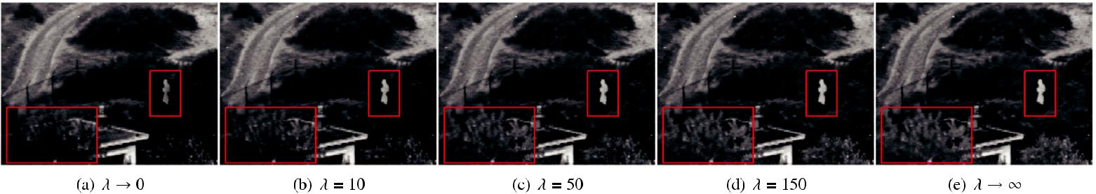

Fig. 7. Fusion results obtained by the hybrid-MSD method with different parameter λ. (For interpretation of the references to color in this figure, the reader is referred to the web version of this article.)

20 Z. Zhou et al. / Information Fusion 30 (2016) 15–26

¹ More obvious comparisons can be seen in the Supplementary material.

Typically, a higher value of λ would make the injected IR spectral fea-tures become more salient in the fused image, and thus make a bet-ter fusion of the source images. However, it is also possible that more unnatural contrasts and details derived from the IR spectrum are in-troduced into the fused image. In this case, a worse fusion result un-pleasant for human visual perception would be obtained.
Fig. 7 presents the fusion results of the “UN Camp” source images obtained by using different λ including the extreme cases of λ → 0 and λ → ∞. We can see that when the value of λ is as small as 0, only a very small amount of IR spectral information is injected into the visible image. As λ is increased, the IR spectral features (e.g., the man labeled in the red rectangles) become more salient, and simultane-ously the background scenery from the visible image is gradually en-hanced (see the trees labeled in the red rectangles). However, when λ is suﬃciently large, the image contrasts on this scenery would be over enhanced to become unnatural for human observer¹.
We observe that a human perception inspired quality metric pro-posed by Chen and Varshney [26] is a interesting indicator that can somewhat reflect the aforementioned observation. The Chen– Varshney metric predicts image fusion quality by comparing the vi-sual differences between the fused and input images. First of all, the images are divided into nonoverlapped local regions. Error images over these local regions are obtained by computing the differences between the fused image and each input image respectively. They are then filtered by a human contrast sensitive function (CSF) in the frequency domain. Next, the similarity measure in each local region is obtained as the mean squared value of the corresponding CSF fil-tered image. The final global quality measure is the weighted sum-mation over all of the nonoverlapping regions. More details on this metric are described in [26], in which the authors also suggest three
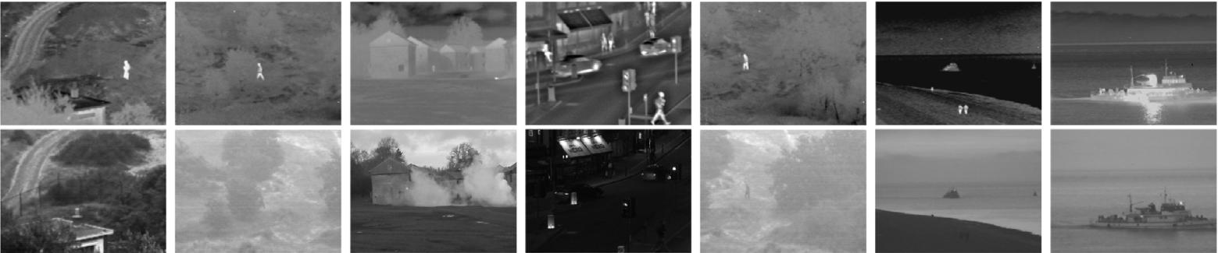

a b c d e f g

Fig. 9. Some of the infrared and visible source images used in our tests, namely (a) Un Camp, (b) Trees4917, (c) Octec, (d) Bristol Queens Road, (e) Trees4906, (f) Kayak, and (g) Steamboat.

coarse-scale information at the base level, in which we typically set
σ_{b} = 4σ_{s,N} .

3.3. Parameter influences

The regularization parameter λ in Eq. (16) serves to control the relative amount of IR spectral information injected into the visible image in a soft manner. Possible values of λ can be selected in (0, ∞). When λ approaches to 0, we can easily obtain that
λ 0 | _{λ}(α) = α
lim S |  | , | (21)
→

and while λ → ∞, S_{λ}(α) evolves to become a unite step function

choices of CSF. Here we use the Mannos–Sakrison filter in our inves-tigation. Fig. 8(a) shows the fusion qualities with respect to differ-ent λ in terms of the Chen–Varshney metric for the fusion results of “UN Camp” source images. Smaller metric values indicate better fusion for human perception. Comparative evaluation based on this metric reveals that our fusion method achieves worse results both in the extreme cases of λ → 0 and λ → ∞, while gets the best result at a certain value between the two extreme cases. More assessments for other three sets of source images (see Fig. 9) can be also seen in Fig. 8(b)–(d).

4. Experimental results and comparisons

that is

0, α = 0 _{λ}^{lim} ^{S}λ^{(α)} ⁼ _{1,} ₀ < _{α} ≤ _{1.}

→∞

The proposed fusion method was tested by subjective and ob-jective assessments. Various conventional pixel-level MSD-based fu-

- sion methods including the LAP, GP, ROLP, DT-CWT and NSCT (non-subsampled contourlet transform) [27,28] are compared in the ex-
periments. We use a four-level decomposition of the hybrid-MSD, in which we set σ_{s,0} = 2, σ_{r,0} = 0.1. In a performance comparison of dif-ferent MSDs for image fusion, Li et al. [29]demonstrate that the NSCT usually achieves the best fusion performance for infrared–visible im-ages. In our experimental comparisons, we use the optimal settings for the NSCT and DT-CWT methods suggested by Li et al. in [29].

The optimal selection of λ for our fusion method may vary de-pending on the source images. However, it is a soft parameter that a modest change of the value would not make a significant variation in the fusion quality. This makes it possible to smoothly adjust the fu-sion result according to user preferences by using this parameter in

practice. In our implementation, we use λ = 30 as a default initial set-ting. Some of the test visible and infrared source images² are shown in Fig. 9.

Fig. 10 shows a fusion example by the proposed hybrid-MSD method on the “Trees4917” source images. The fusion results from the ROLP, DT-CWT and NSCT methods are presented to be compared with that of the proposed method. We can see that the hybrid-MSD method successfully transfers the important IR spectral features into the fused image, while simultaneously the background and details from the visible image are also properly preserved. This results in a better visual fusion result compared with the fused images obtained by the ROLP, DT-CWT and NSCT methods. For example, in Fig. 10(d)–

(f) the trees (as labeled in the red rectangles) are hard to be identified due to the influences of the improperly introduced IR spectral infor-mation.

Fig. 11 presents the fusion results of the “Octec” source images from different MSD-based fusion methods. As shown in Fig. 11(c), the hidden structures of the houses and person in the visible image are all clearly fused into the fusion result by the hybrid-MSD method.

² The source images were collected from http://www.imagefusion.org/.

Z. Zhou et al. / Information Fusion 30 (2016) 15–26 | 21
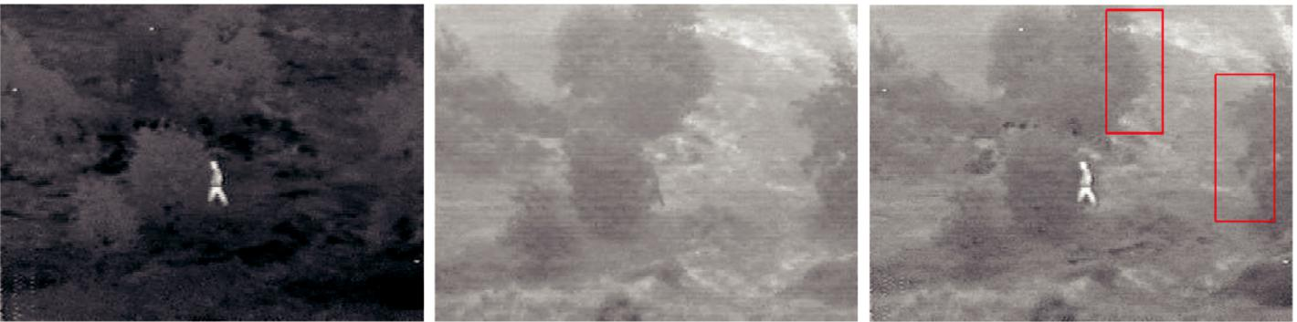

(a) Infrared image (b) Visible image (c) Hybrid-MSD
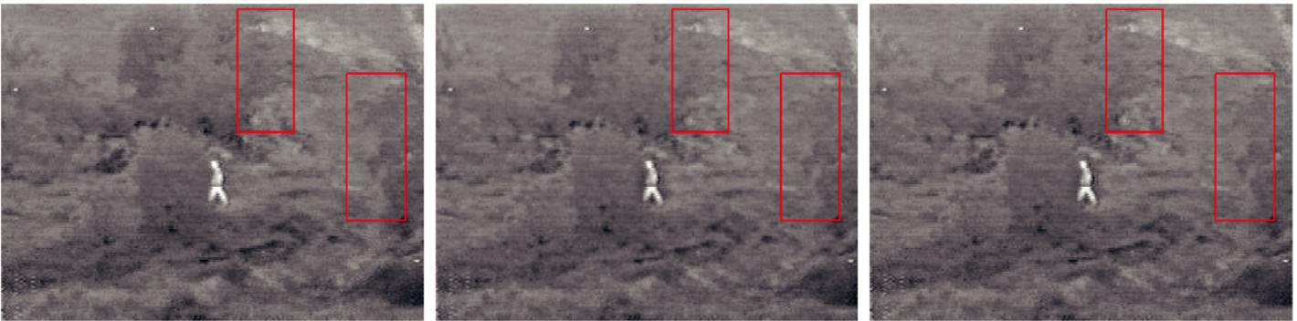

(d) LAP (e) DT-CWT (f) NSCT

Fig. 10. Fusion results of the “Trees4917” source images obtained by different fusion methods. (For interpretation of the references to color in this figure, the reader is referred to the web version of this article.)
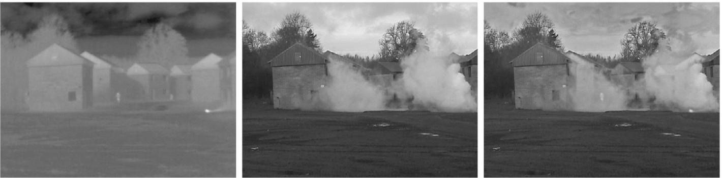

(a) Infrared image (b) Visible image (c) Hybrid-MSD
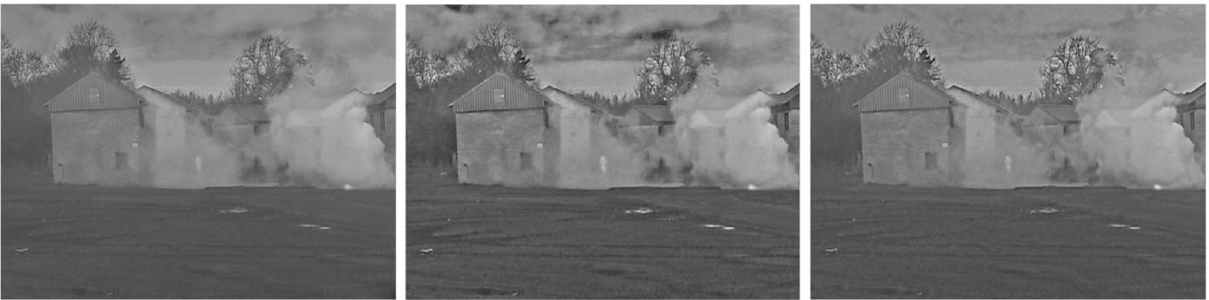

(d) GP (e) ROLP (f) NSCT

Fig. 11. Fusion results of the “Octec” source images obtained by different fusion methods.

In addition, the overall tones and contrasts of the visible image are well preserved to allow for better visual perceiving. In the fusion results from the GP and NSCT methods, the background sceneries are contaminated by the blurry IR spectral information, due to that the two methods both tend to fuse all the irrelevant details into the fusion results. In Fig. 11(e) the fused image obtained by the ROLP

method seems over enhanced with unnatural contrasts that are in-consistent with human visual perceiving experiences. In contrast, the fusion result from the hybrid-MSD method looks more natural and pleasing.

A fusion example for night vision on the “Bristol Queens Road” source images is presented in Fig. 12. Close-up views for labeled

22 Z. Zhou et al. / Information Fusion 30 (2016) 15–26
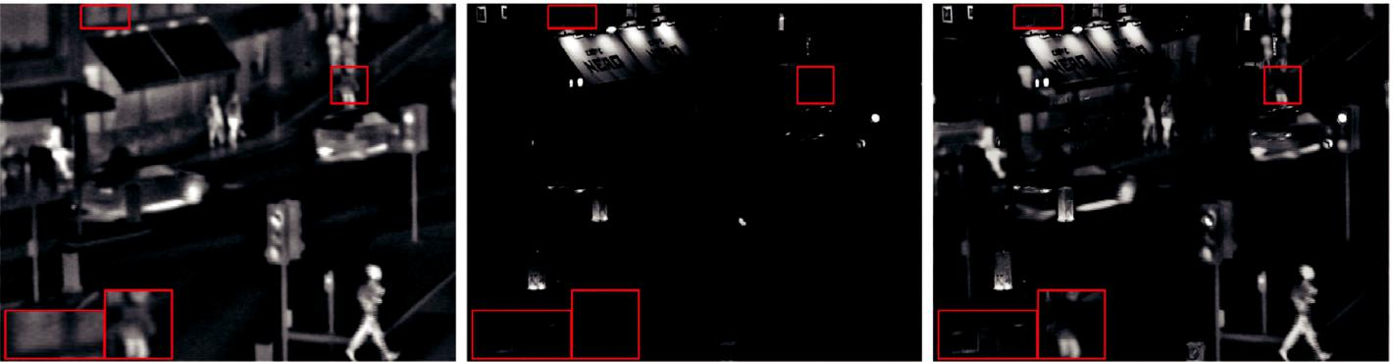

(a) Infrared image (b) Visible image (c) Hybrid-MSD
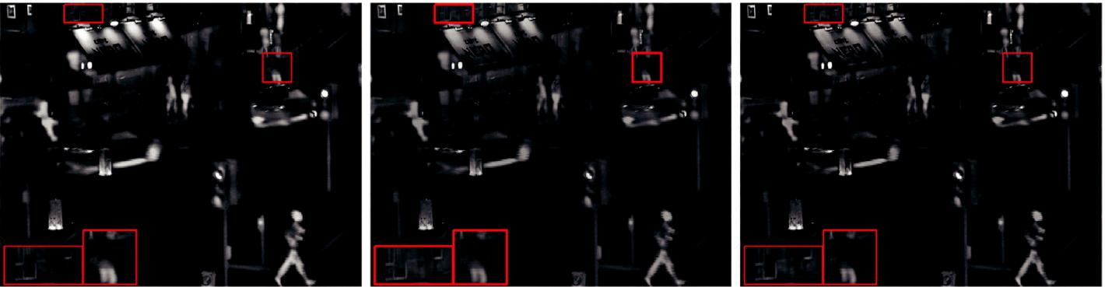

(d) LAP (e) GP (f) NSCT

Fig. 12. Comparison of the fusion results from different methods on the “Bristol Queen’s Road” source images.

Table 1

The quantitative assessments of different fusion methods on the source images shown in Fig. 9(a)–(d) (the best results are highlighted in bold).

Images | Index | LAP | ROLP | GP | DT-CWT | NSCT | Hybrid-MSD
UN Camp | LMI | 0.1733 | 0.1756 | 0.1761 | 0.1601 | 0.1685 | 0.2223
 | IE | 6.7103 | 6.7558 | 6.3499 | 6.5724 | 6.5557 | 6.8232
 | Q^{M} | 262.87 | 350.62 | 248.29 | 257.53 | 259.26 | 234.31
 | Pref. | 0.6462 | 0.5385 | 0.2000 | 0.4462 | 0.3846 | 0.7846
Trees4917 | LMI | 0.1462 | 0.1464 | 0.1529 | 0.1378 | 0.1418 | 0.1614
 | IE | 5.9389 | 6.0083 | 5.7184 | 5.8372 | 5.8380 | 6.1832
 | Q^{M} | 255.74 | 267.80 | 250.22 | 250.15 | 250.76 | 235.84
 | Pref. | 0.5846 | 0.5538 | 0.1385 | 0.2923 | 0.5077 | 0.8923
Octec | LMI | 0.2144 | 0.2122 | 0.2364 | 0.2051 | 0.2171 | 0.3155
 | IE | 6.4961 | 6.6415 | 6.3341 | 6.5584 | 6.4459 | 6.9756
 | _{Q}M | 179.55 | 242.47 | 220.74 | 202.61 | 194.39 | 83.654
 | Pref. | 0.5231 | 0.4769 | 0.3231 | 0.2308 | 0.3846 | 0.9846
Queen’s Road | LMI | 0.2241 | 0.1897 | 0.2379 | 0.1922 | 0.2032 | 0.2017
 | IE | 6.4762 | 6.1759 | 6.0608 | 6.1728 | 6.1955 | 6.3775
 | Q^{M} | 435.09 | 841.17 | 550.09 | 537.34 | 518.01 | 344.66
 | Pref. | 0.4462 | 0.6308 | 0.1846 | 0.4769 | 0.4615 | 0.8000

regions are presented in the bottom-left of the source and fused images. As shown in Fig. 12(c), the hybrid-MSD method appropriately enhances the scenery of the night-time visible image by injecting a proper amount of IR spectral information. We can see that the fused image looks more natural as a night-time image. However, the fu-sion results from the LAP and NSCT methods shown in Fig. 12(d) and

(f) seem to be unnaturally enhanced by the IR spectral information, whereas the visible image information fused in Fig. 12(e) by the GP method is not clear enough. From the close-up views, it can be also seen that the hybrid-MSD method can clearly enhance the details of the windows and make a better fusion for the rider.

Table 1 shows the quantitative comparisons of the fusion results from different methods for the above source images. The fusion qual-ity indexes including localised mutual information (LMI) [30], infor-mation entropy (IE) and the Chen–Varshney metric (denoted as Q^{M}) are employed in the objective evaluation. The index LMI estimates

the joint information between the fused image and source images by applying the classic mutual information metric on local blocks, so that the local structural similarity can also be considered. The index IE evaluates image fusion performance by measuring the amount of information contained in the fused image. In addition, the index Q^{M} is also used since it demonstrates good predictive performance for human perception. From Table 1 we can see that overall the hybrid-MSD method outperforms the other fusion methods in terms of these indexes, except that the GP and LAP methods achieve the highest val-ues of LMI and IE respectively for the “Bristol Queens Road” source images.

Figs. 13–15 present the fusion results from different methods on the “Trees4906”, “Kayak” and “Steamboat” source images, respec-tively. The fused images obtained by using the parameter λ → ∞ are also presented in these figures. This can be achieved by using the nonlinear function given in Eq. (22) or by setting a significantly large

Z. Zhou et al. / Information Fusion 30 (2016) 15–26 | 23
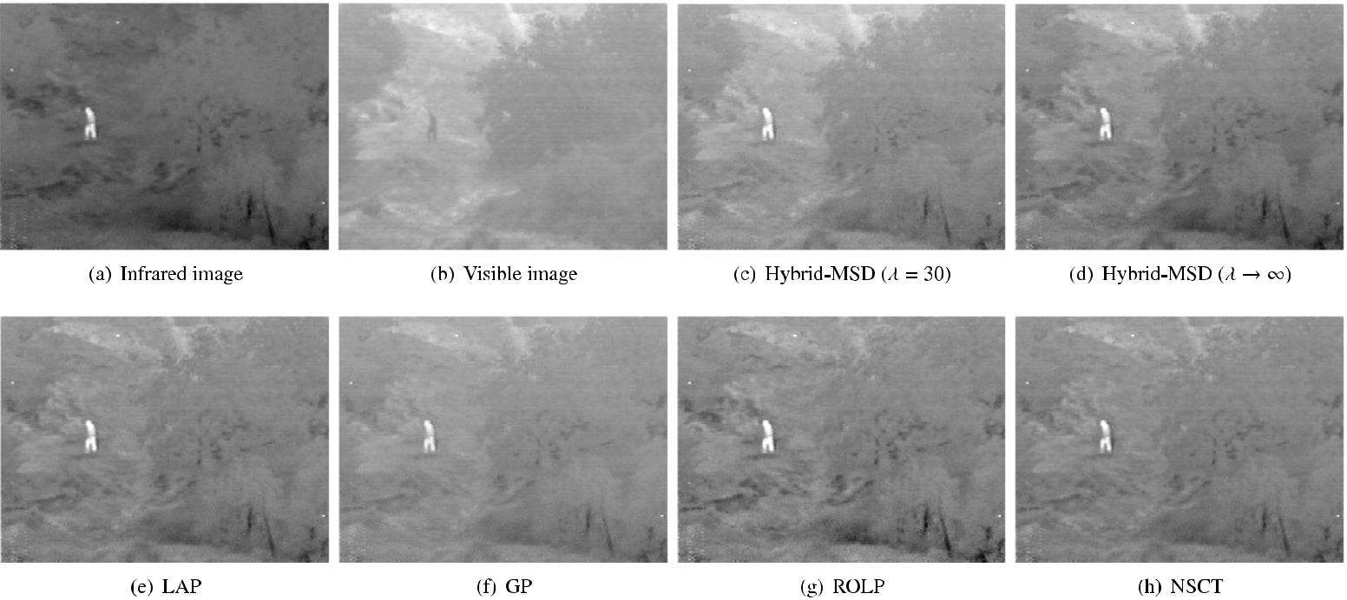

Fig. 13. Comparison of the fusion results from different methods on the “Trees4906” source images.
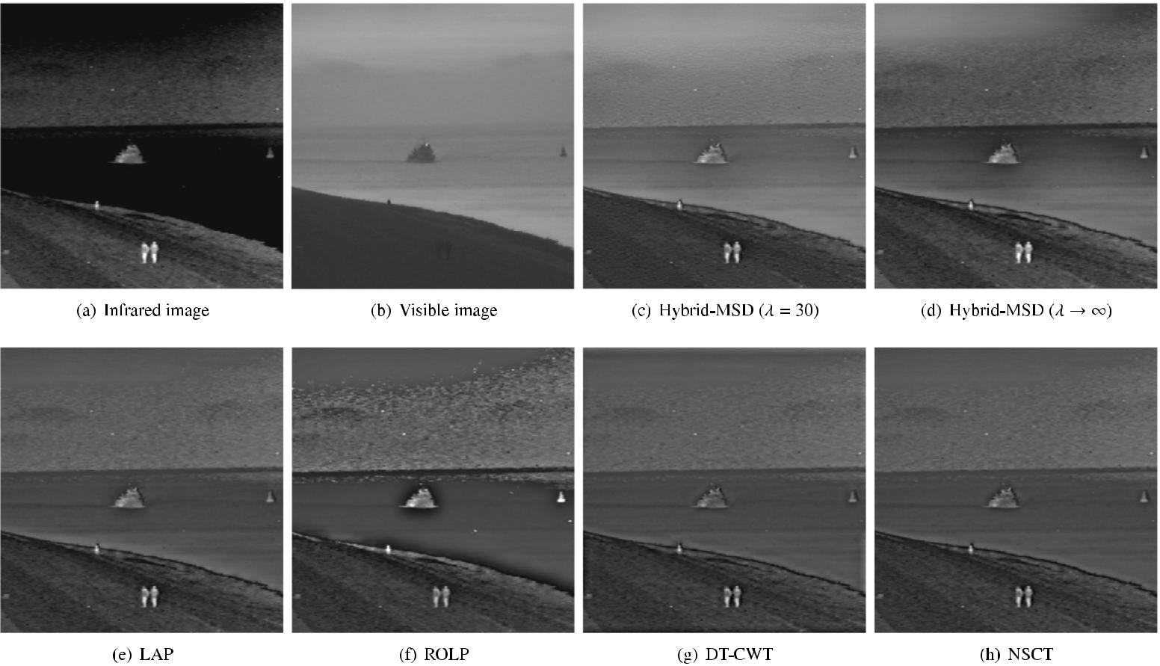

Fig. 14. Comparison of the fusion results from different methods on the “Kayak” source images.

value of λ (e.g., λ = 3000). We can see for the “Trees4906” source images in Fig. 13, the IR spectral information can be further injected to enhance the visible image without obviously degrading the image background contents. In this case, using λ→ ∞ would obtain better fusion result. Also, in Fig. 14 suﬃcient IR spectral information should be injected into the visible image to enhance the image contents on the beach. For the “Steamboat” source images shown in Fig. 15, since all the important information of two source images is focused on the target of steamboat, and the water background scenery in the visible

image contains little useful information, suﬃcient IR spectral infor-mation is also needed to fully enhance the steamboat target with higher value of λ. Quantitative comparisons of different fusion meth-ods on the three fusion examples are presented in Table 2. From the quantitative assessments, we can also see that the hybrid-MSD method using λ → ∞ can perform better than that employing λ = 30 in terms of the Chen-Varshney metric as well as the majority of other index values. Overall, the hybrid-MSD method can achieve the best fusion results compared with the other fusion methods, except for

24 Z. Zhou et al. / Information Fusion 30 (2016) 15–26
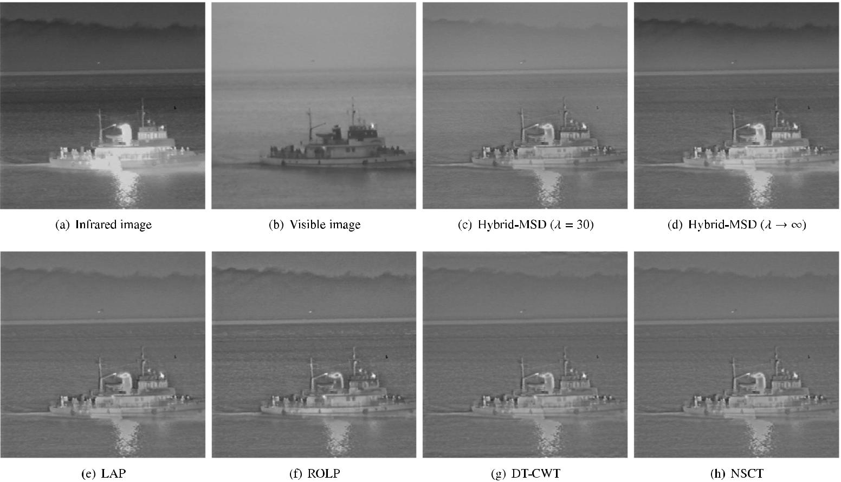

Fig. 15. Comparison of the fusion results from different methods on the “Steamboat” source images.

Table 2

The quantitative assessments of different fusion methods on the source images shown in Fig. 9(e)–(g) (the best results are highlighted in bold).

Images | Index | LAP | ROLP | GP | DT-CWT | NSCT | Hybrid-MSD (λ = 30) | Hybrid-MSD (λ → ∞)
Trees4906 | LMI | 0.1736 | 0.1734 | 0.1905 | 0.1699 | 0.1727 | 0.2182 | 0.1916
 | IE | 6.1154 | 6.1722 | 5.9663 | 6.0560 | 6.0457 | 6.4731 | 6.7528
 | Q^{M} | 268.82 | 281.27 | 273.96 | 270.36 | 269.42 | 435.66 | 258.33
 | Pref. | 0.5769 | 0.3077 | 0.2179 | 0.3077 | 0.4103 | 0.8077 | 0.8205
Kayak | LMI | 0.2602 | 0.2210 | 0.3039 | 0.2227 | 0.2556 | 0.2881 | 0.2362
 | IE | 6.1915 | 6.4494 | 5.9747 | 6.1598 | 6.1150 | 6.7258 | 6.5081
 | _{Q}M | 298.93 | 464.37 | 316.23 | 320.51 | 313.85 | 458.78 | 250.68
 | Pref. | 0.6923 | 0.0513 | 0.4487 | 0.4615 | 0.4744 | 0.4872 | 0.8590
Steamboat | LMI | 0.1565 | 0.1459 | 0.1650 | 0.1401 | 0.1513 | 0.1608 | 0.2065
 | IE | 5.3169 | 5.4345 | 5.0198 | 5.2009 | 5.1728 | 5.6003 | 6.2531
 | _{Q}M | 236.60 | 279.01 | 231.63 | 246.58 | 240.42 | 302.76 | 195.90
 | Pref. | 0.5513 | 0.6154 | 0.3077 | 0.4359 | 0.4615 | 0.4744 | 0.5641

the GP method in terms of the index LMI on the “Kayak” source images.

Subjective tests based on human observers are also conducted to compare the fusion results from different MSD-based fusion meth-ods. We adopt a subjective evaluation scheme proposed by Petrovic [31] to ask the observers to find the preferred image in each pair of fused images. In our perceptual evaluation trials, all the fused im-ages from six fusion methods are compared to each other by form-ing 123 fused image pairs on the above seven sets of source images (the parameter settings of λ = 30 and λ → ∞ are both used for the hybrid-MSD method on the three sets of source images shown in Figs. 13–15), and then they are shown to the subjects³ in random or-der. Observers were informed to express their individual preferences by more considering the image (they feel) that (1) looks more nat-ural and comfortable for visual perception; (2) contributes more to quick scene awareness and target recognition; (3) provides more and

³ Consist of 13 unexperienced graduated students at Beijing Institute of Technology.

clearer useful detail information to aid for accurate understanding of the image. All the images were presented on a 20 in. PC-monitor, for which the settings have been adjusted interactively with the assis-tance of display calibration utilities prior to the test to ensure a good display quality. The viewing distance and environmental conditions were both kept during this test as those described in [31], such as keeping the viewing distance in the range of 0.6 − 0.8 m and testing in a quiet and relatively darkened room.

The preference for image 1 or image 2 in each fused image pair is recorded as a binary vector:

[1, 0] | image 1
[0, 1] | image 2 | (23)
S = _{[0,} _{0]} | no preference.
The total number of received preference T_{i} for fusion method i (i = 1, 2, . . . , 6) is calculated based on the binary vectors given by all subjects. The human preference score H_{i} for each fusion method is

Z. Zhou et al. / Information Fusion 30 (2016) 15–26 | 25

a b
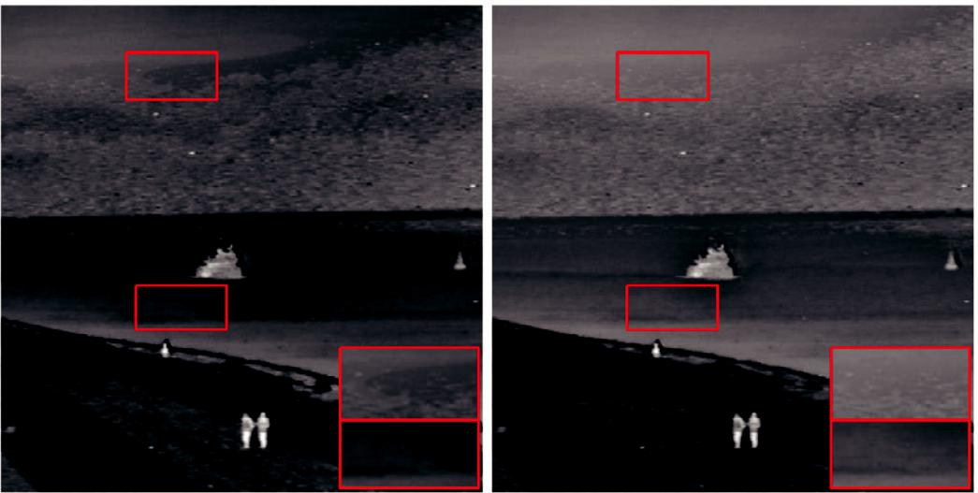
Fig. 16. Fusion results of the “Kayak” source images obtained by using five-level de-composition in our fusion method when λ → ∞. (a) Fused image with obvious artifacts and (b) the artifacts have been alleviated by using λ = 30 at the base level.

defined as:
H_{i} = | ^{T}i | , | (24)
H_{i} = | MN_{i} | , | (24)
where M is the number of subjects, and N_{i} denotes the number of image pairs in which the fused image from method i is contained.

The obtained preference scores are presented in Tables 1 and 2 (denoted as “Pref.”) for each evaluated fusion result. In Table 1 it is confirmed apparently that the hybrid-MSD method provides per-ceptually better fusion results than the other fusion methods. From Table 2 we can see that the hybrid-MSD method outperforms the other methods both for the “Trees4906” and “Kayak” source images when λ → ∞, and for the “Trees4906” source images it also achieves the best performance when λ = 30. However, for the “Steamboat” source images, the ROLP method performs a bit better than the hybrid-MSD method. This is probably because the visible source im-age lacks informative background scenery in addition to the water, and the local luminance contrasts in the steamboat target have been highlighted by the ROLP method as shown in Fig. 15(f). From the subjective test, we can also observe that when the infrared image contains clusters of perceptual details, injecting more amount of IR spectral information with significantly higher value of λ(e.g., λ → ∞) would obtain better fusion result for human perception.

Another observation on our fusion method is that the fusion result is more sensitive to the number of used decomposition levels com-pared to conventional multi-scale fusion algorithms. This is primarily due to the different treatments of different scales in the combina-tion algorithms and that at the base level the weighting coeﬃcients depend on the higher scale-level decomposed information. Typically, for the source images with a specific size, a proper number of de-composition levels would make the information at almost all scales fused into the fusion result. However, when the same source images are substantially enlarged, more decomposition levels should be re-quired in order to achieve the magnified version of similar fusion result. Besides, we observe that too large number of decomposition
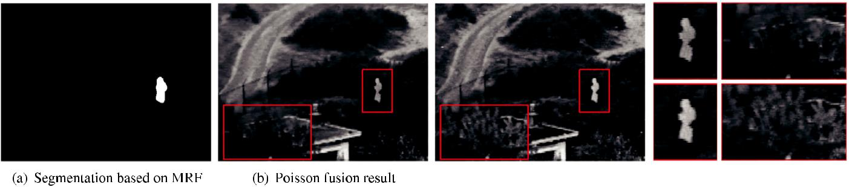
levels would also produce obvious artifacts when we set λ → ∞ for some source images. The generation of these artifacts may be par-tially because of the staircase effect of the bilateral filter [32]. An ex-ample for the “Kayak” source images is shown in Fig. 16. When we use a five-level decomposition of the hybrid-MSD, artifacts occur in Fig. 16(a) as more clearly shown in the close-up views. Since such effect tends to occur firstly in the low-frequency subband, a simple way for alleviation is to use a much smaller λ (e.g., λ = 30) when determining the base-level weighting coeﬃcients according to Eqs. (19)and (20). The result is shown in Fig. 16(b). In our implementation, we find that four-level decomposition is a suﬃciently good choice for all test images.

Finally, a brief comparison with a region-based fusion method re-ferred to as Poisson image fusion [33] is given in Fig. 17 to demon-strate some additional superiorities of our method. The Poisson im-age fusion method merges the salient regions in the infrared image and the background scenery from the visible image to achieve a bet-ter visual fusion result. Salient regions in the infrared image are seg-mented first based on the Markov Random Field (MRF) model (see Fig. 17(a)), and then they are merged into the visible image accord-ing to the corresponding fusion weights by solving the Poisson equa-tion in gradient domain. The final fusion result of the “UN Camp” source images is shown in Fig. 17(b). We can see that the Poisson fusion result successfully preserves the background scenery of the visible image. However, it suffers from obvious halo-effect around the target object (the dark area around the person) as reported in [33]. In contrast, although our fusion performs at the pixel-level, it can also merge the salient region from the infrared image and si-multaneously avoid the halo-effect (see Fig. 17(c) and the close-up views in Fig. 17(d)). Moreover, from the close-up views it is obviously revealed that the trees become clearer in our fusion result. This is because the proposed fusion method also enables to incorporate a certain amount of IR spectral information to properly enhance the background scenery.

5. Conclusion

In this paper, we propose a novel multi-scale image fusion method based on a hybrid multi-scale decomposition (namely hybrid-MSD) transform for perceptual fusion of the infrared and visible images. Unlike conventional MSD transforms, the hybrid-MSD integrates multi-scale Gaussian and bilateral filters to decompose the source images into multi-scale texture details and edge features. Particu-larly, it can be used to identify and select important IR spectral fea-tures from the infrared image to inject them into the visible image. By further employing different combination algorithms adaptively ac-cording to different information scale levels in the fusion process, we can preserve or properly enhance the background scenery and de-tails from the visible image which provide important perceptual cues for human observation. Experimental results demonstrate that the proposed fusion method is able to provide perceptually better fusion results compared with various other pixel-based multi-scale fusion algorithms.

Fig. 17. Comparison with the Poisson fusion method on the “UN Camp” source images.

26 Z. Zhou et al. / Information Fusion 30 (2016) 15–26

Acknowledgments

The authors would like to thank the anonymous reviewers for their constructive comments. This work is supported by the National Natural Science Foundation of China under Grant no. 61403033. More fusion results can be seen in the Supplementary material.

Supplementary material

Supplementary material associated with this article can be found, in the online version, at 10.1016/j.inffus.2015.11.003 .

References

- A.M. Waxman, A.N. Gove, D.A. Fay, J.P. Racamato, J.E. Carrick, M.C. Seibert, E.D. Savoye, Color night vision: opponent processing in the fusion of visible and IR imagery, Neural Netw. 10 (1) (1997) 1–6.

- A. Toet, Natural colour mapping for multiband nightvision imagery, Inf. Fusion 4

(3) (2003) 155–166.

- M.A. Hogervorst, A. Toet, Fast natural color mapping for night-time imagery, Inf. Fusion 11 (2) (2010) 69–77.

- A. Akerman III, Pyramidal techniques for multisensor fusion, Proc. SPIE 1828 (1992) 124–131.

- P.J. Burt, R.J. Kolczynski, Enhanced image capture through fusion, in: Proceedings of International Conference on Computer Vision, 1993, pp. 173–182.

- G. Pajares, J. Manuel de la Cruz, A wavelet-based image fusion tutorial, Pattern Recognit. 37 (9) (2004) 1855–1872.

- S. Yang, M. Wang, L. Jiao, Fusion of multispectral and panchromatic images based on support value transform and adaptive principal component analysis, Inf. Fu-sion 13 (3) (2012) 177–184.

- A. Toet, L.J. Van Ruyven, J.M. Valeton, Merging thermal and visual images by a contrast pyramid, Opt. Eng. 28 (7) (1989) 287789.

- P.H. Nishan, P. Hill, N. Canagarajah, D. Bull, Image fusion using complex wavelets, in: Proceedings of British Machine Vision Conference, 2002, pp. 487–496.

- J.J. Lewis, R.J. O’Callaghan, S.G. Nikolov, D.R. Bull, N. Canagarajah, Pixel- and region-based image fusion with complex wavelets, Inf. Fusion 8 (2) (2007) 119– 130.

- F. Nencini, A. Garzelli, S. Baronti, L. Alparone, Remote sensing image fusion using the curvelet transform, Inf. Fusion 8 (2) (2007) 143–156.

- S. Yang, M. Wang, L. Jiao, R. Wu, Z. Wang, Image fusion based on a new contourlet packet, Inf. Fusion 11 (2) (2010) 78–84.

- S. Yang, M. Wang, L. Jiao, Contourlet hidden Markov Tree and clarity-saliency driven PCNN based remote sensing images fusion, Appl. Soft Comput. 12 (1) (2012) 228–237.

- A. Toet, E.M. Franken, Perceptual evaluation of different image fusion schemes, Displays 24 (1) (2003) 25–37.

- T. Lindeberg, Scale-space Theory in Computer Vision, Kluwer Academic Publish-ers, Netherlands, 1994.

- C. Tomasi, R. Manduchi, Bilateral filtering for gray and color images, in: Proceed-ings of International Conference on Computer Vision, 1998, pp. 839–846.

- E. Eisemann, F. Durand, Flash photography enhancement via intrinsic relighting, in: Proceedings of ACM SIGGRAPH, 23, 2004, pp. 673–678.

- F. Durand, J. Dorsey, Fast bilateral filtering for the display of high-dynamic-range images, in: Proceedings of ACM SIGGRAPH, 21, 2002, pp. 257–266.

- S. Bae, S. Paris, F. Durand, Two-scale tone management for photographic look, in: Proceedings of ACM SIGGRAPH, 25, 2006, pp. 637–645.

- G. Petschnigg, R. Szeliski, M. Agrawala, M. Cohen, H. Hoppe, K. Toyama, Digital photography with flash and no-flash image pairs, in: Proceedings of ACM SIG-GRAPH, 23, 2004, pp. 664–672.

- R. Fattal, M. Agrawala, S. Rusinkiewicz, Multiscale shape and detail enhancement from multi-light image collections, in: Proceedings of ACM SIGGRAPH, 26, 2007, p. 51.

- E.P. Bennett, J.L. Mason, L. McMillan, Multispectral bilateral video fusion, IEEE Trans. Image Process. 16 (5) (2007) 1185–1194.

- S. Paris, F. Durand, A fast approximation of the bilateral filter using a signal pro-cessing approach, in: Proceedings of European Conference on Computer Vision, 2006, pp. 568–580.

- Q. Yang, K.-H. Tan, N. Ahuja, Real-time O(1) bilateral filtering, in: Proceedings of IEEE Conference on Computer Vision and Pattern Recognition, 2009, pp. 557– 564.

- J. Sporring, J. Weickert, Information measures in scale-spaces, IEEE Trans. Inf. The-ory 45 (3) (1999) 1051–1058.

- H. Chen, P.K. Varshney, A human perception inspired quality metric for image fusion based on regional information, Inf. Fusion 8 (2) (2007) 193–207.

- A.L. Da Cunha, J. Zhou, M.N. Do, The nonsubsampled contourlet transform: the-ory, design, and applications, IEEE Trans. Image Process. 15 (10) (2006) 3089– 3101.

- B. Yang, S. Li, F. Sun, Image fusion using nonsubsampled contourlet transform, in: Proceedings of International Conference on Image and Graphics, 2007, pp. 719– 724.

- S. Li, B. Yang, J. Hu, Performance comparison of different multi-resolution trans-forms for image fusion, Inf. Fusion 12 (2) (2011) 74–84.

- M. Hossny, S. Nahavandi, D. Creighton, A. Bhatti, Image fusion performance metric based on mutual information and entropy driven quadtree decomposition, Elec-tron. Lett. 46 (18) (2010) 1266–1268.

- V. Petrovic,´ Subjective tests for image fusion evaluation and objective metric val-idation, Inf. Fusion 8 (2) (2007) 208–216.

- S. Paris, P. Kornprobst, J. Tumblin, F. Durand, A gentle introduction to bilateral filtering and its applications, in: Proceedings of ACM SIGGRAPH 2007 Courses, 2007.

- J. Sun, H. Zhu, Z. Xu, C. Han, Poisson image fusion based on Markov random field fusion model, Inf. Fusion 14 (3) (2013) 241–254.

